**Database System Practical 9**

**Tables:**

**Sailors:** **Reserves:**

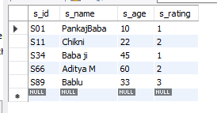 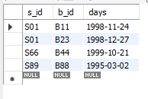

**Boats:**

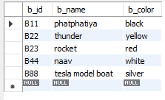

**Q1: Find the age of youngest sailors for each rating level.**

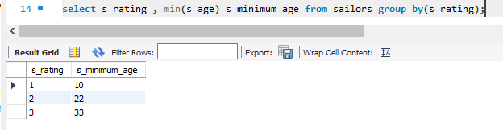

**Q2: Find the age of youngest sailor who is eligible to vote for each rating level with at least two such sailor.**

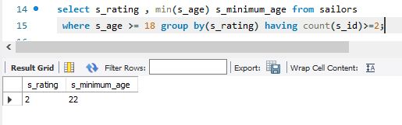

**Q3: For each red boat, find the number of reservations for this boat.**

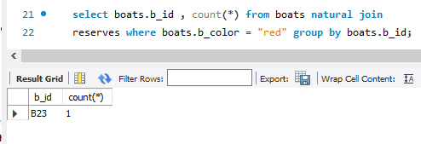

**Q4: Find average age of sailor for each rating level that has at least two such sailors.**

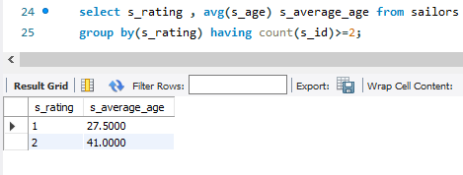

**Q5: Write a query to print the following sentence:**

**Sailor named ………. with sailor id………. has reserved boat number………. on date…………….**

